# Chemistry Unit 1

# Assignment #1

**Bonding in Household Products**

1. **Copper**

**Type of bonding, arrangement of particles and the nature of the attractive forces that exist between particles**

* Bonding in Copper is **Metallic bonding**. It is the strong attraction between **closely packed** positive metal ions and a 'sea' of delocalised electrons. The **electrostatic force of attraction** that holds Copper atoms together; acts between negatively charged delocalised valence electrons and positively charged metal cations.

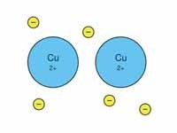

**The properties of the substance and an explanation of how these properties are related to the structure and bonding within the substance**

1. **High melting point**

There are strong forces of electrostatic attraction between copper 2+ions and delocalised electrons, therefore it requires a large amount of energy to break these bonds.

1. **Electrical conductivity**

When melted, both the delocalised electrons and the positive metal ions are able to act as mobile charge carriers, therefore copper conduct electricity in the liquid state.

1. **Thermal conductivity**

When metals are heated the mobile delocalised electrons gain kinetic energy. They move rapidly through the solid metal and transfer their energy to other particles.

1. **Malleability & Ductility**

The force of attraction between copper ions and delocalised electrons is non-directional. When a force is applied a row of ions is able to move into a new position without breaking metallic bonds.

**The uses of the substance in the home, and an explanation of how these uses are dependent on the properties of the substance.**

**Uses**

Copper can easily be shaped into pipes and drawn into wires.

|  |  |
| --- | --- |
|  | * Copper pipes are lightweight because they can have thin walls * They don't corrode and they can be bent to fit around corners. * Pipes can be joined by soldering * They are safe in fires because they don't burn or support combustion. |

Copper used in special tools and military applications.

* non magnetic and non sparking

Used in mains cables in houses and underground

* Copper wires allow electric current to flow without much loss of energy
* Small electrical [resistance](javascript:showGloss(%22resi%22)).

Use for pipes, electrical cables, saucepans and radiators.

* Copper is low in the [reactivity series](javascript:showGloss(%22reacs%22)) (doesn't tend to corrode)

1. Sodium chloride

**Type of bonding, arrangement of particles and the nature of the attractive forces that exist between particles**

* **Ionic bonds** form when a metal reacts with a non-metal.
* Involve the **electrostatic force of attraction** between positively charged cations and negatively charged anions; results in an ionic compound with a three-dimensional lattice structure.

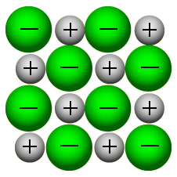

* **The oppositely charged ions are arranged in a regular way to form giant ionic *lattices*. Ionic *compounds* often form crystals as a result.**

**The properties of the substance and an explanation of how these properties are related to the structure and bonding within the substance**

1. High melting point

A large amount of energy needed to overcome strong electrostatic attractions between ions which are present in the fixed position in the lattice.

1. Electrical conductivity

Do not conduct when solid - ions are held strongly in the lattice. Conduct when molten or in aqueous solution - the ions become mobile and conduction takes place**.** 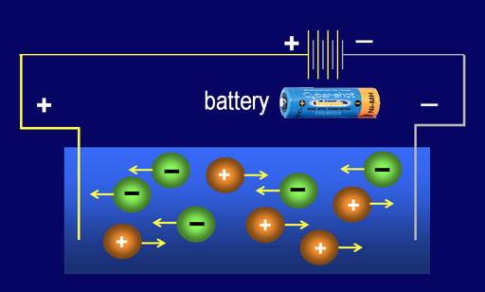

1. Strength: Hard but brittle

Ions are held rigidly in place in the lattice but the application of stress brings ions of the same charge close together , repulsion causes the crystal to shatter.

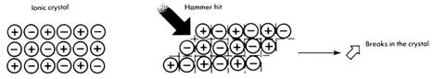

1. Solubility

Most soluble in water. Water is a polar solvent, ions are attracted to water molecules and move out of position, but they are insoluble in non-polar solvents.

**The uses of the substance in the home, and an explanation of how these uses are dependent on the properties of the substance.**

Sodium chloride is a desiccant.

* cheap and safe

[salting](https://en.wikipedia.org/wiki/Salting_(food)) an effective method of [food preservation](https://en.wikipedia.org/wiki/Food_preservation)

* the salt draws water out of bacteria through [osmotic pressure](https://en.wikipedia.org/wiki/Osmotic_pressure), keeping it from reproducing,

Adding salt in foods

* Salt essentially soaks up the water, creating a “dry” environment where it is difficult for the bacteria that spoil food to grow.
* Salt also draws water from the moist insides of bacteria to the drier environment, killing them.
* Add a little salt and almost everything tastes better.

1. Ammonia

**Type of bonding, arrangement of particles and the nature of the attractive forces that exist between particles**

Hydrogen atoms can each **form** one covalent **bond**, while and nitrogen atoms can each **form** three covalent **bonds**. Three pairs of electrons are shared in an **ammonia** molecule (NH3).

Covalent bonding is the electrostatic forces of attraction between electrons and the nucleus of more than one atom.

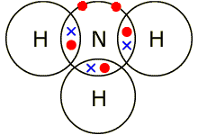

**The properties of the substance and an explanation of how these properties are related to the structure and bonding within the substance**

1. The solubility of ammonia is mainly due to the hydrogen bonding
2. ammonia also reacts with the water to produce ammonium ions and hydroxide ions.

http://www.chemguide.co.uk/atoms/structures/nh3h2oeq.GIF

1. Low melting and boiling points- because the intermolecular forces of attraction are comparatively weak.
2. Non-conductors of electricity

**The uses of the substance in the home, and an explanation of how these uses are dependent on the properties of the substance.**

ammonia is used as fertilizers

* helps provide increased yields of crops such as maize and wheat

Solutions of ammonia (5–10 percent by weight) are used as household cleaners, particularly for glass.

ammonia is added to drinking water

Use in domestic [refrigeration](http://www.newworldencyclopedia.org/entry/Refrigeration)

* more or less non-toxic and non-flammable,

During the 1960s, began using ammonia in cigarettes.

* enhances the delivery of nicotine into the bloodstream.
* nicotine’s reinforcement effect was enhanced, increasing its addictive ability without increasing the proportion of nicotine.[[19]](http://www.newworldencyclopedia.org/entry/Ammonia#cite_note-18)

1. Graphite

**Type of bonding, arrangement of particles and the nature of the attractive forces that exist between particles**

**Graphite is a covalent compound.**

**In graphite, the carbon atoms are arranged in flat parallel layers. Within each layer, each carbon atom is covalently bonded to three other carbon atoms, forming a hexagonal arrangement. Therefore, each layer is a two-dimensional network of carbon atoms.**

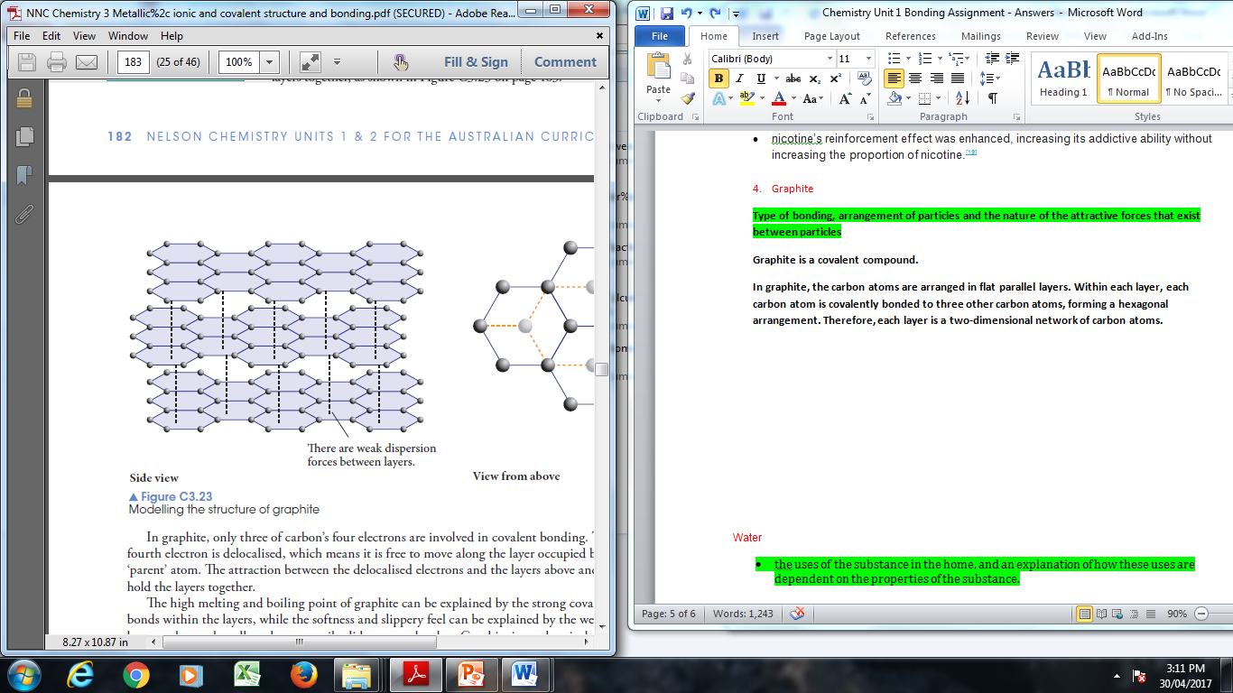

Weak dispersion forces are existing between the layers.

**The properties of the substance and an explanation of how these properties are related to the structure and bonding within the substance**

1. The high melting and boiling point of graphite can be explained by the strong covalent bonds within the layers
2. Softness and slippery feel can be explained by the weak bonds between layers that allow them to easily slide over each other
3. Graphite is an electric conductor due to presence of the delocalised electrons that can move and therefore conduct electricity.

**The uses of the substance in the home, and an explanation of how these uses are dependent on the properties of the substance.**

It is used inside pencils.

* **ability to leave grey marks on paper.**

graphite has long been used as a lubricant

* graphite flakes slip over one another, giving it its greasy feel

it is used to make pads

t's used in Li ion batteries in cell phones and tablets (and other devices), plus in many types of dry cell battery.

* Conducts electricity

It's used in Li ion batteries in cellphones and tablets (and other devices), plus in many types of dry cell battery.

It is used in some types of filter you might use at home,

* for getting rid of smells

use graphite in my bicycle locks,

* keeps them working well.

Water

* the uses of the substance in the home, and an explanation of how these uses are dependent on the properties of the substance.

Water has a number of roles in living organisms:

* **solvent**
* **temperature buffer**
* **metabolite**
* **living environment**

is a **metabolite** in many reactions, either as a reactant or as a product of reaction. For example, it's involved in **photosynthesis**, **digestion** and **aerobic** **respiration**.

* When water reacts with a chemical to break it into smaller molecules (the reaction is described as **hydrolysis)**.
* When water is formed as one of the products when two molecules join together the reaction is described as **condensation**.

**solvent**

* A wide range of molecular compounds also dissolve in water, including sugars, amino acids, small nucleic acids and proteins. All these molecules are **polar**. This means they have a positive end and a negative end as the result of polar covalent bonds within them.
* The water acts as a solvent for chemical reactions and also helps transport dissolved compounds into and out of cells.

## Living environment

provides a living environment for some organisms

* In freezing weather, ice forms on the surface of ponds and lakes forming an insulating layer above the water below. This provides a living environment for some organisms until the ice melts. Organisms can also live under the ice.
* Ice floats on water. This is because ice is less dense than water.

support small insects such as pond skaters.

* The surfaces of ponds and lakes (and other forms of water) are covered in a 'skin' of water molecules. The skin forms because of the increased attraction between water molecules (**cohesive forces**) at the surface.